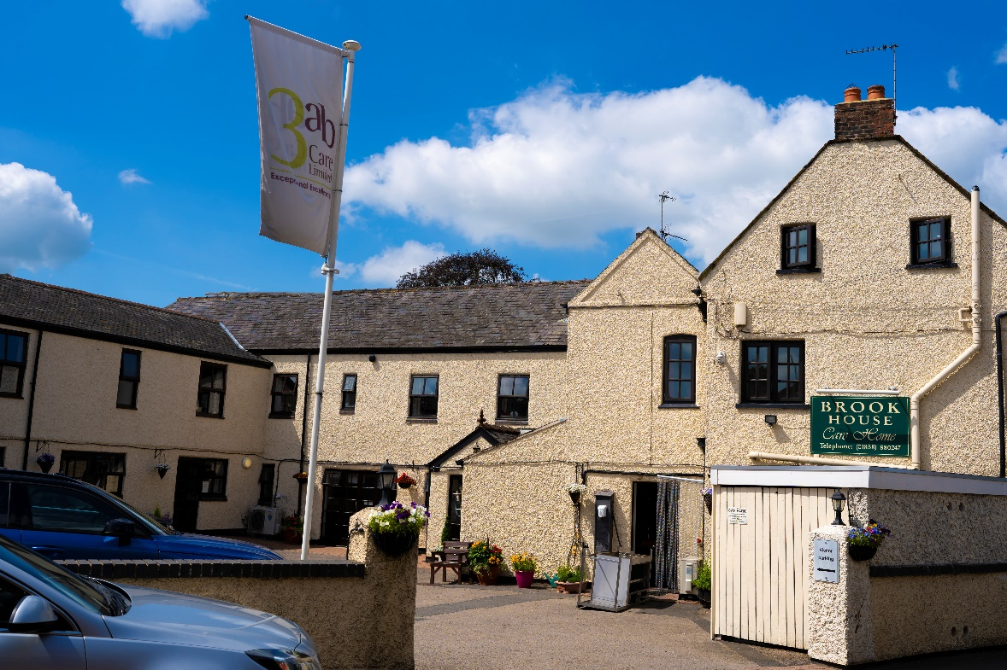


Brook House information pack 2024

Our Philosophy of Care

At Brook House Care Home, we aim to provide each service user with a comfortable and homely environment in which security, independence and dignity is maintained

About our Home

Brook House Care Home is a converted former farmhouse situated in the picturesque village of Husband Bosworth. After serving as a farmhouse for many years the building was then used as a Veterinary Surgery and then converted into the Residential home as it stands today. The village is situated in South Leicestershire some ten miles from Leicester city centre and 5 miles from the market town of Market Harborough.

There is a good bus service from the village to all surrounding areas. There is also easy access to the M1 motorway and routes into Leicestershire and Northamptonshire.

In the village of Husbands Bosworth, a short 2-minute walk away there is a Village school, a Post Office, a General Store, A village Hall, a Church and a Village pub.

Brook House offers both single and double bedroom accommodation, all with en-suite facilities, for up to 41 residents. The property has 2 levels, all offering comfortable homely rooms. All rooms are tastefully decorated to enhance the cosy atmosphere of the home. We have a lovely courtyard garden, where residents can sit under the parasols weather permitting

The Senior staff and Junior care assistants are dedicated, caring, and hardworking, all with the same goal; ensuring the residents receive the care and attention they require, and to ease any anxieties they have, so they are happy and relaxed, and enjoy their time with us.

Mrs Michelle Hood is the manager and is supported by a Deputy Managers, Rosie Crossan & Karen Brett and a number of Senior and junior staff. There will always be senior member of staff on duty working alongside are a team of trained assistant. If you need to contact Michelle, you can do so on 01858 880247.

We have incorporated the opportunity for our care assistants to benefit from National Vocational Qualification Training. These have been proved to be very successful.

Mrs Krishna Patel is a Director of Brook House Care Home Ltd. and is responsible for the day-to-day running of the home. If you have any questions you would like to ask please do not hesitate to call her on, Tel: 01858 880

Fees
Details for the Fees charged can be obtained from Michelle or Krishna.

Local Services

Hairdressers
We have a unisex hairdresser who visits Brook House every Wednesday and will happily do cuts, perms etc.

Doctors
All our residents are registered with the local doctors for the area, which is organised at time of admission.

Chiropodist, dentist, and physiotherapist
We have a local chiropodist who regularly visits the home. If required, the chiropodist, dentist and physiotherapist can be called upon.

Optician
An optician will visit annually or on request.

Social activities and seasonal special events

At Brook House, we strive to keep our residents as active as possible and do our utmost to keep an ongoing programme of events to as variable as possible. This helps to keep the residents amused/occupied and helps maintain both physical and mental wellbeing.

The home has the use of a minibus to take residents out on trips.

Some of the activities include:

Dominoes/Jigsaw Puzzles

Bingo

Accordionist – playing old time favourites

Craft making

Nail painting/Manicures

Reminiscence

Karaoke

Library books – monthly exchange

Pub lunches, Cream teas, Games nights, Music & movement

We strive to make seasonal events such as Christmas, Easter, Birthdays etc. memorable events for our residents. We organise fetes, B.B.Q’s etc. at these important times of the year. All monies raised at these events go into a resident’s fund to give them extra little treats, such as visits on the canal, railway/seaside trips.

We are open to suggestions from residents, staff, and relatives to make these trips as successful and enjoyable as possible.

Trips can be anything from visiting a garden centre for as afternoon cup of tea, a drive through the countryside, visits to the beach, picnics etc.

Our staffs are only too happy to give up their free time to help organise these events, as they see how important and enjoyable, they are to our residents.

Visiting
Brook House has an open visiting policy, we welcome visitors at all times. The relatives are free to choose as to where they want to visit, either their rooms for privacy or lounge for more comfort if they so wish.

You can also take the residents out if you wish to do so. There are no restrictions. We do, however, ask you sign in/out of our visitor’s book to conform to fire regulations.

Smoking
We operate a strict no smoking policy at Brook House. However we do allow residents who do smoke to be able to do so in the courtyard.

Laundry
We have a laundry assistant at Brook House who is responsible for the washing and ironing of all residents clothing. We do request that all items of clothing be clearly labelled.

Catering
At Brook House, we have experienced cooks who provide homemade, wholesome, and nutritious meals. The menu is varied and caters for specialised diets such as diabetic, low fat or vegetarian meals. We believe in giving our residents a choice of menu, and we like to make mealtimes relaxed, enabling the residents to enjoy their meal.

- Breakfast is served between 6.30am and 10.00am.
- Dinner is served in the dining rooms at 12.30pm
- Tea is served at 3.00pm – tea/coffee, homemade cake/biscuits
- Supper is served at 5.00pm in the dining room.

Questions for you to consider

We realise what a difficult and hard decision it is to have to find a home for your family member.

Listed below are questions/observations to be made before making this very important choice as to where your relative’s new home will be. We hope they will assist you.

- Is there a waiting list?
- How much will it cost – what does this cost cover?
- Is there a contract?
- Does the home accept residents funded by the local authority?
- Is there a trial period for the new residents?
- How much choice does the resident have?
- Are residents allowed to bring in personal possessions?
- Do residents have to share a room?
- Do rooms have their own toilet facilities?
- Where are the toilets situated in relation to residents’ rooms?
- Are there adequate stair lifts/fire escapes?
- Is medication supervised?
- What happens if a resident has to go into hospital?
- What happens when a resident dies – funerals etc?
- Will the residents religious needs be catered for?
- What are the homes staffing levels?
- Look at the residents – do they look happy?

Whilst you are viewing the home, please feel free to stop and talk to any of the staff or residents and ask any questions you feel fit. We believe it is important for you to know first-hand the standard of care that we provide at the home. Our staff and current residents will provide you with the most reliable information in making your decision to choose Brook House for your relative.

Get in touch

If you would like to speak to our teams or send us an enquiry simply contact us using the details below or visit the website www.3abcare.co.uk

Contacts:
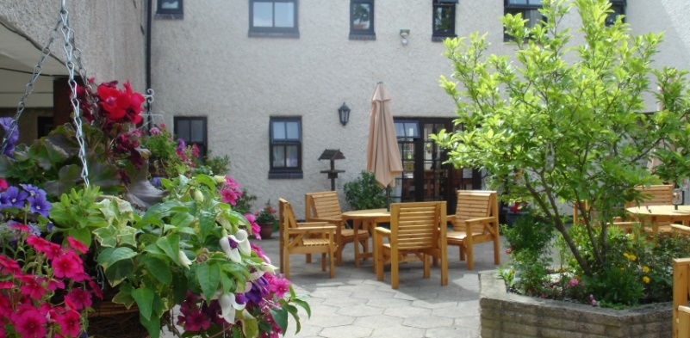
Krishna Patel – Director
Michelle Hood - Manager

15 Bell Lane
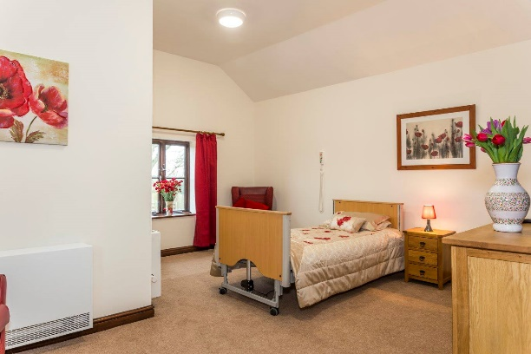
Husbands Bosworth
Leicestershire
LE17 6LA

Tel: 01858 880247
Email: brookhouse@3abcare.co.uk
Web: www.3abcare.co.uk

